Experiment 3: 4-bit Full Adder/Subtractor Experiment

Name:Infeter Md (尹飞翔)

Student ID: 202237026

Design a 4-bit Full Adder/Subtractor using a 4-bit full adder designed in experiment 2. Use this device to perform the operation, and design a truth table for testing.

NOTE:

1、Every experiment requires writing an experimental report.

2、The experimental report should include at least the experimental screenshot and the experimental results.

3、The experiments require designing circuits and truth value tables by yourself.

**Truth table of 4-bit serial carry parallel adder**

|  |  |  |  |  |  |
| --- | --- | --- | --- | --- | --- |
| INPUT | | OUTPUT | | | |
| A4 A3 A2 A1 | B4 B3 B2 B1 | C1 |  | C1 |  |
| 0001 | 0010 | 0 | 0011 | 1 | 1111 |
| 1001 | 1100 | 1 | 0101 | 0 | 1101 |
| 0011 | 1011 | 0 | 1110 | 0 | 1000 |
| 1011 | 1100 | 1 | 0111 | 0 | 1111 |
| 0101 | 1010 | 0 | 1111 | 0 | 1011 |
| 1100 | 0011 | 0 | 1111 | 1 | 1001 |
| 1001 | 1100 | 1 | 0101 | 0 | 1101 |
| 1010 | 0110 | 1 | 0000 | 1 | 0100 |

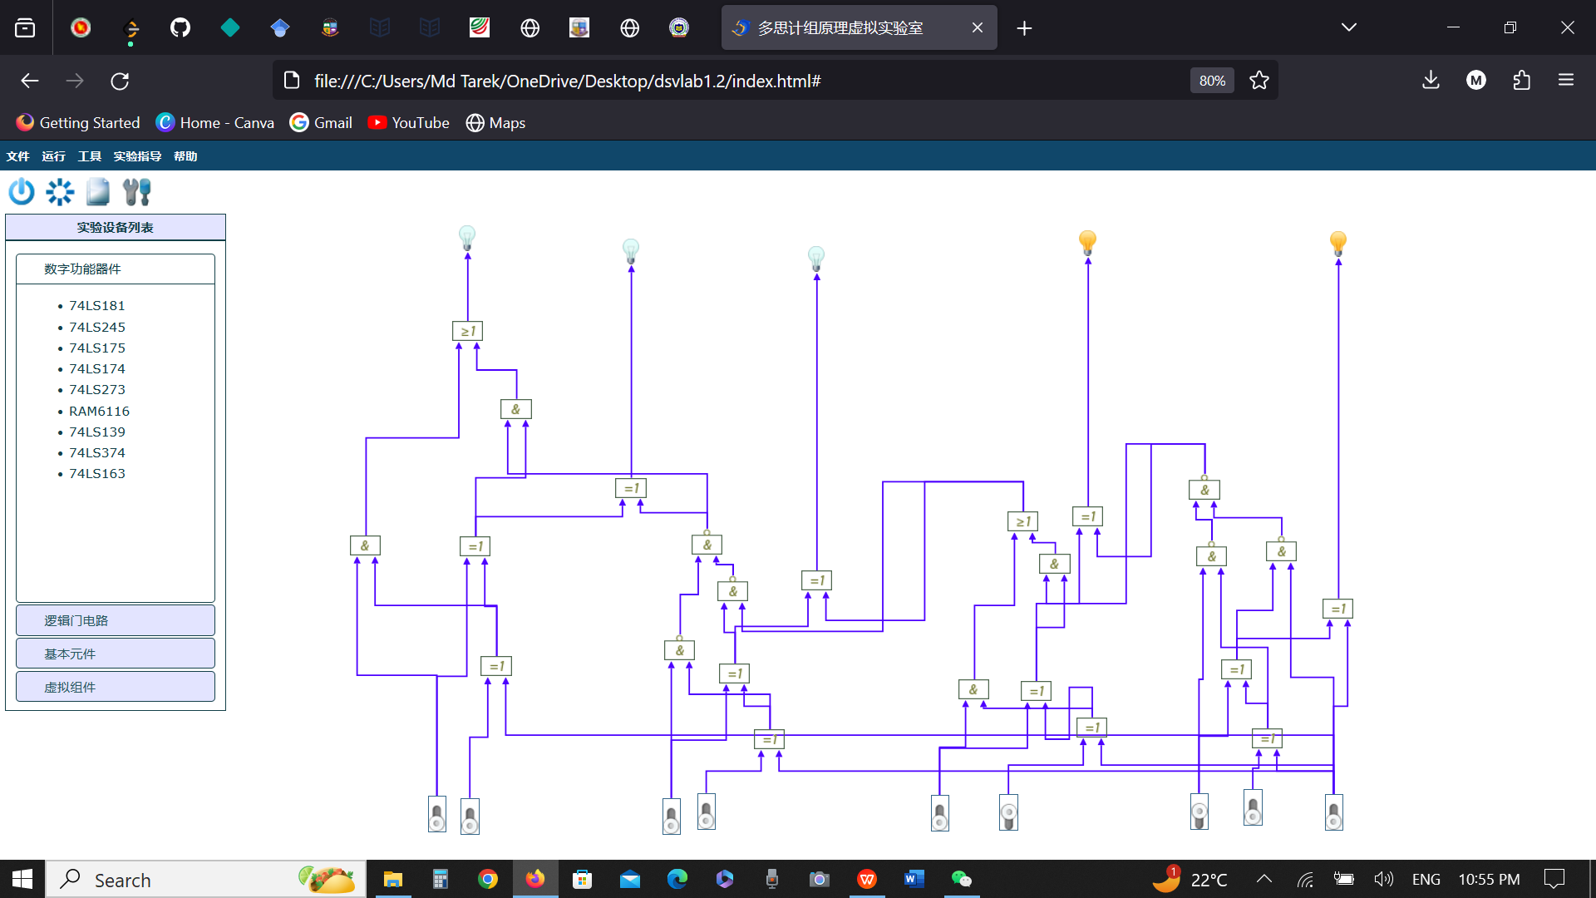

Figure: Circuit Diagram and Output